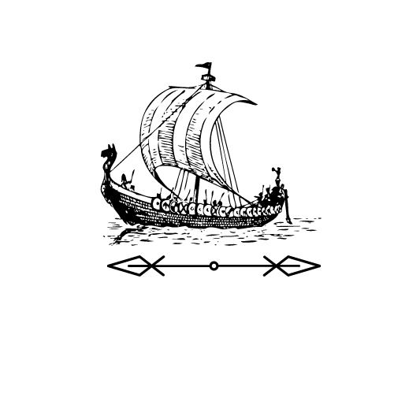
Extract from Enthralled: A Viking Saga
by Chris Wright, Chapter 2.

From the point of view of Chester

As we left the entrance hall, a hush fell over the place, as if the museum itself was trying to keep the secret of our escape. Walking through the deserted halls, I found myself whispering.
“Look,” I murmured, gesturing to an open door to our right.
Through it, I could just make out what looked like the curving front of a ship. A viking ship!
“Awesome!” Freya exclaimed, and I winced as her voice echoed back at us from the bare walls of the corridor.
I didn’t have time to tell her to keep it down before she took off in the direction of the room and bounded energetically inside. I followed.
Music, soft and tinkling but with a strange beauty, met my ears as I crossed into
the hall of the ship exhibit. Freya had stopped in the entryway, her mouth agape
at the sight that greeted her. Dominating the room was an ancient ship, on loan,
a sign told me, from a museum in Norway. The thousand years or so that had
passed since it was built had eaten away at the wood, and the entire thing was
supported by a new metal frame, with large holes all over the hull.

Questions

1. What does the word ‘hush’ mean?

________________________________________________________________

2. Why does Chester wince when Freya exclaims, ‘Awesome!’?

She hurt him She is being too loud

She found a viking ship He’s scared of her

3. What does it mean when it says that Freya’s mouth is ‘agape?

________________________________________________________________

________________________________________________________________

4. What suggests that Chester is more nervous here than Freya?

________________________________________________________________

________________________________________________________________

________________________________________________________________

5. Why does the ship have a metal frame?

To make it look cool To support it

Ships were made of metal To stop people climbing on it

6. Why are there holes in the wood of the ship?

________________________________________________________________

________________________________________________________________

7. Who goes into the room with the ship first?

________________________________________________________________

8. Summarise how Chester feels throughout this extract.
________________________________________________________________

________________________________________________________________

________________________________________________________________

________________________________________________________________

Extract from Enthralled: A Viking Saga
by Chris Wright, Chapter 2.

From the point of view of Chester

As we left the entrance hall, a hush fell over the place, as if the museum itself was trying to keep the secret of our escape. Walking through the deserted halls, I found myself whispering.
“Look,” I murmured, gesturing to an open door to our right.
Through it, I could just make out what looked like the curving front of a ship. A viking ship!
“Awesome!” Freya exclaimed, and I winced as her voice echoed back at us from the bare walls of the corridor.
I didn’t have time to tell her to keep it down before she took off in the direction of the room and bounded energetically inside. I followed.
Music, soft and tinkling but with a strange beauty, met my ears as I crossed into
the hall of the ship exhibit. Freya had stopped in the entryway, her mouth agape
at the sight that greeted her. Dominating the room was an ancient ship, on loan,
a sign told me, from a museum in Norway. The thousand years or so that had
passed since it was built had eaten away at the wood, and the entire thing was
supported by a new metal frame, with large holes all over the hull. Even so, it was beautiful. A real Viking longboat – all sleek lines, curving beams and carved wood.
All I could do was stare at it. Freya, I could sense, was moving around behind
me – she never could stay still for long – but I was rooted to the floor, taking in
every detail.

Questions

1. What does the word ‘hush’ mean?

________________________________________________________________

2. Why does Chester wince when Freya exclaims, ‘Awesome!’?

________________________________________________________________

________________________________________________________________

3. What does it mean when it says that Freya’s mouth is ‘agape?

________________________________________________________________

________________________________________________________________

4. How are Chester and Freya behaving differently in this extract?

________________________________________________________________

________________________________________________________________

________________________________________________________________

5. Why does the ship have a metal frame?

________________________________________________________________

________________________________________________________________

6. It says the ship is ‘dominating the room’. What does this imply?

The ship is old The ships is creaking

The ship is wooden The ship is big

7. Who goes into the room with the ship first?

________________________________________________________________

8. Summarise how Chester feels throughout this extract.
________________________________________________________________

________________________________________________________________

________________________________________________________________

________________________________________________________________

9. What does it mean by Chester being ‘rooted to the floor’? Why is he rooted there?

________________________________________________________________

________________________________________________________________

________________________________________________________________

________________________________________________________________
Answers
Lower Question Set

1. What does the word ‘hush’ mean?
Quiet

2. Why does Chester wince when Freya exclaims, ‘Awesome!’?
She is being too loud.

3. What does it mean when it says that Freya’s mouth is ‘agape?
Accept both her mouth being wide open and her feeling stunned.

4. What suggests that Chester is more nervous here than Freya?
He is quiet while she is loud. She is moving more quickly and carefree.

5. Why does the ship have a metal frame?
To support it.

6. Why are there holes in the wood of the ship?
Because it is old or answers that connect to its age and wear.

7. Who goes into the room with the ship first?
Freya.

8. Summarise how Chester feels throughout this extract.
Must mention him being nervous, unsure or reticent. Can also mention awe and similar emotions surrounding the ship.

Answers
Higher Question Set

1. What does the word ‘hush’ mean?
Quiet

2. Why does Chester wince when Freya exclaims, ‘Awesome!’?
She is being too loud.

3. What does it mean when it says that Freya’s mouth is ‘agape?
Accept both her mouth being wide open and her feeling stunned.

4. How are Chester and Freya behaving differently in this extract?
Chester is more nervous/unsure. Freya is more careless and excitable

5. Why does the ship have a metal frame?
To support it.

6. It says the ship is ‘dominating the room’. What does this imply?
The ship is big.

7. Who goes into the room with the ship first?
Freya.

8. Summarise how Chester feels throughout this extract.
Must mention him being nervous, unsure or reticent. Can also mention awe and similar emotions surrounding the ship.

9. What does it mean by Chester being ‘rooted to the floor’? Why is he rooted there?
He is stood still on the spot because he is in awe/shocked/admiring the ship.

