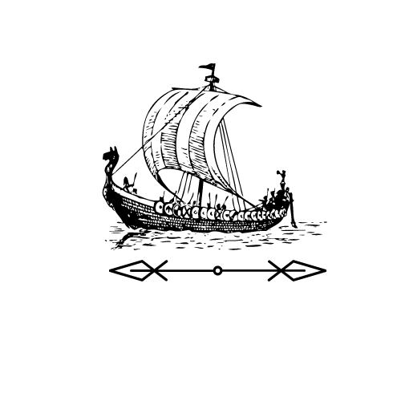
Extract from Enthralled: A Viking Saga
by Chris Wright, Chapter 3.

From the point of view of Chester

The sudden, piercing sunlight seared into my eyes. I almost let go of the boat to
shade them, but then my whole world tipped, and I had to grip tighter to stop
myself from being thrown overboard. The sea where we had landed (can you
land on water?) tumbled all around us. Desperately, I tried to cling on, but I was
tossed from one side to the other, battered again and again into the wood, the
breath knocked from my lungs. I had seen no sign of rain through the darkness
in the museum, but now it pelted down all around me.
No singing reached my ears then. In fact, I could hear nothing but the roaring of
the wind and the waves. I tried to look for Freya, but my vision only spun with
the motion of the boat, and when I tried to shout for her, I got only a mouthful
of salty water. My eyes stung as it sprayed all around me, and I felt like I would
be sick, but I swallowed hard and clung on for my life.

Questions

1. Why did Chester have to grip tightly to the ship?

________________________________________________________________

2. What does it mean when it says the sunlight is ‘piercing’?

It is sudden It is sharp

It is very bright It is dim

3. ‘Desperately, I tried to cling on...’ How might Chester be feeling here?

________________________________________________________________

4. What is the weather like in this extract?

________________________________________________________________

5. What does the word ‘roaring’ tell you about the wind and waves?

They are very loud They are very big

They came very suddenly They are throwing Chester around

6. Where do you think Freya might be?

________________________________________________________________

________________________________________________________________

7. Why does Chester ‘swallow hard’?

________________________________________________________________

________________________________________________________________

Extract from Enthralled: A Viking Saga
by Chris Wright, Chapter 3.

From the point of view of Chester

The sudden, piercing sunlight seared into my eyes. I almost let go of the boat to
shade them, but then my whole world tipped, and I had to grip tighter to stop
myself from being thrown overboard. The sea where we had landed (can you
land on water?) tumbled all around us. Desperately, I tried to cling on, but I was
tossed from one side to the other, battered again and again into the wood, the
breath knocked from my lungs. I had seen no sign of rain through the darkness
in the museum, but now it pelted down all around me.
No singing reached my ears then. In fact, I could hear nothing but the roaring of
the wind and the waves. I tried to look for Freya, but my vision only spun with
the motion of the boat, and when I tried to shout for her, I got only a mouthful
of salty water. My eyes stung as it sprayed all around me, and I felt like I would
be sick, but I swallowed hard and clung on for my life.
Then, all at once, there was a moment of stillness. Only a moment, little more than a second, but it was enough for me to see. And I saw nothing but grey. Endless ocean and endless sky, with no sign of the museum we had left. And no sign of Freya.

Questions

1. Why did Chester have to grip tightly to the ship?

________________________________________________________________

2. What does it mean when it says the sunlight is ‘piercing’?

3. ‘Desperately, I tried to cling on...’ How might Chester be feeling here?

________________________________________________________________

4. Why do Chester’s eyes sting?

He is trying not to cry He is scared about losing Freya

He needs glasses He has salt water in them

5. What does the word ‘roaring’ tell you about the wind and waves?

6. Where do you think Freya might be? Why do you think this?

________________________________________________________________

________________________________________________________________
7. Why does Chester ‘swallow hard’?

________________________________________________________________

________________________________________________________________

8. What does ‘endless ocean and endless sky’ tell you?

________________________________________________________________

________________________________________________________________

9. Summarise the events of this chapter.

________________________________________________________________

________________________________________________________________

________________________________________________________________

________________________________________________________________

Answers
Lower Question Set

1. Why did Chester have to grip tightly to the ship?
To stop himself from being thrown overboard.

2. What does it mean when it says the sunlight is ‘piercing’?
It is very bright.

3. ‘Desperately, I tried to cling on...’ How might Chester be feeling here?
Scared, bewildered or similar

4. What is the weather like in this extract?
Stormy, mentions of rain, wind etc.

5. What does the word ‘roaring’ tell you about the wind and waves?
They are loud.

6. Where do you think Freya might be? Why do you think this?
In the sea, on the boat somewhere, in the museum & other justified answers.

7. Why does Chester ‘swallow hard’?
To stop himself from being sick.

Answers
Higher Question Set

1. Why did Chester have to grip tightly to the ship?
To stop himself from being thrown overboard.

2. What does it mean when it says the sunlight is ‘piercing’?
It is bright.

3. ‘Desperately, I tried to cling on...’ How might Chester be feeling here?
Scared, bewildered or similar

4. Why do Chester’s eyes sting?
He has salt water in them

5. What does the word ‘roaring’ tell you about the wind and waves?
They are loud.

6. Where do you think Freya might be? Why do you think this?
In the sea, on the boat somewhere, in the museum & other justified answers.

7. Why does Chester ‘swallow hard’?
To stop himself from being sick.

8. What does ‘endless ocean and endless sky’ tell you?
There is no land nearby

9. Summarise the events of this chapter.
A summary that mentions rough seas, clinging to the boat etc.

